# ­Chapter 4: High-Level Database Models

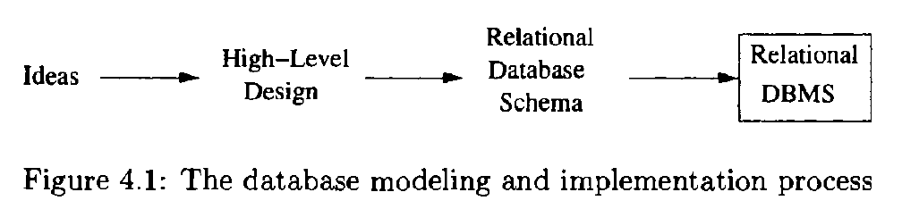

## 4.1 The Entity /Relationship Model

In the entity-relationship model (or E/R model), the structure of data is represented graphically, as an "entity-relationship diagram," using three principal element types:

1. Entity sets,
2. Attributes, and
3. Relationships.

### 4.1.1 Entity Sets

An entity is an abstract object of some sort, and a collection of similar entities forms an entity set. An entity in some ways resembles an "object". The E/R model is a static concept, involving the structure of data and not the operations on data.

### 4.1.2 Attributes

Entity sets have associated attributes, which are properties of the entities in that set.

|  |
| --- |
| **E/R Model Variations**  In some versions of the E/R model, the type of an attribute can be either:   1. A primitive type, as in tr1e version presented here. 2. A "struct," as in C, or tuple with a fixed number of primitive components. 3. A set of values of one type: either primitive or a "struct" type.   For example, the type of an attribute in such a model could be a set of pairs, each pair consisting of an integer and a string. |

### 4.1.3 Relationships

Relationships are connections among two or more entity sets.

### 4.1.4 E/R Diagrams

An E/R diagram is a graph representing entity sets, attributes, and relationships. Elements of each of these kinds are represented by nodes of the graph, and we use a special shape of node to indicate the kind, as follows:

* Entity sets are represented by rectangles.
* Attributes are represented by ovals.
* Relationships are represented by diamonds.

Edges connect an entity set to its attributes and also connect a relationship to its entity sets.

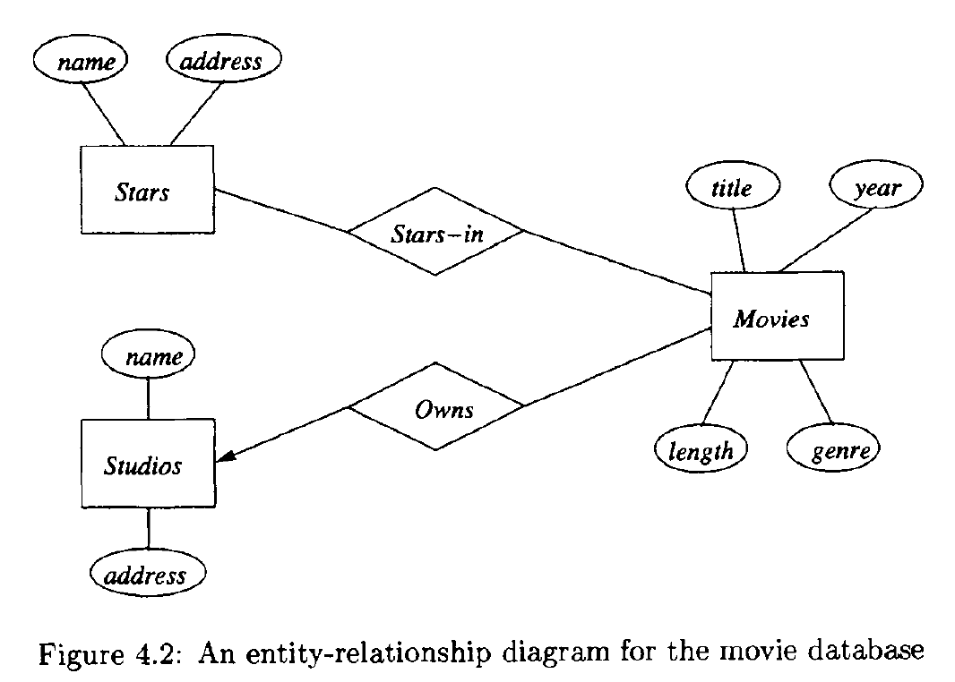

### 4.1.5 Instances of an E/R Diagram

E/R diagrams are a notation for describing schemas of databases.

For each entity set, the database instance will have a particular finite set of entities. Each of these entities has particular values for each attribute. A relationship R that connects n entity sets E1 , E2 , …, En may be imagined to have an "instance" that consists of a finite set of tuples (e., e2 , ... , en), where each Ei is chosen from the entities that are in the current instance of entity set Ei.